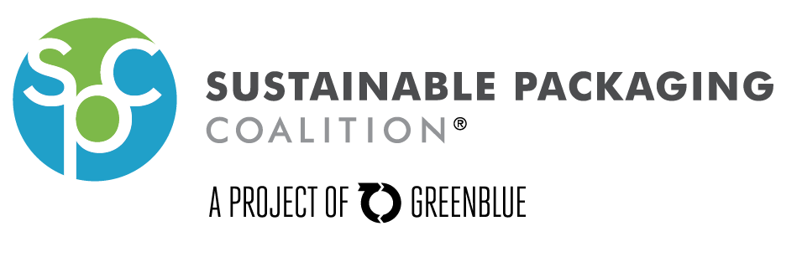
Scaling Up Composting in the Charlotte Region APPLICATION

Large-scale foodservice waste composting has the potential to take approximately one-third of the municipal solid waste stream out of landfills, benefiting the local economy, retaining essential resources, and addressing climate change impact. Businesses in the Charlotte area have a tremendous opportunity to turn waste into value through composting of food scraps and compostable packaging.

The Charlotte project partners seek to build on current efforts to 1) demonstrate successful commercial-scale composting of food waste and foodservice packaging, illustrating economic viability, and 2) develop best practices to accelerate the rate at which sustainable materials management practices are adopted by municipalities and private companies across the U.S.

The project funding is provided by the U.S. EPA Region IV, supplemented by Mecklenburg County funds and in-kind contributions from SPC member dues and the IDEAS Center.
Thank you for your interest in this project!
What Participants Receive
- Funding towards start-up costs for each location, typically for the first month
- Development of a customized collection system, including bins
- A phase-in plan as needed
- Training and signage
- Troubleshooting as needed
- Optional recognition as part of EPA’s Food Recovery Challenge Program

Participant Requirements
In order to track the program success, data from each facility is needed. Individual facility and company data will not be shared publicly; rather, the team will compile the data and report in aggregate. Participants may request a non-disclosure agreement. The following are required:
- Completion of a pre-selection questionnaire
- Collect food scraps
- Consider post-consumer food waste collection and using compostable packaging
- Allow a project representative to observe the collection process and perform a visual waste characterization
- Communicate collection, material handling, or other issues as they arise
- Complete an end-of-project questionnaire (September 2015)
- Provide a quote regarding lessons learned or other points

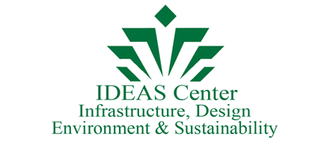
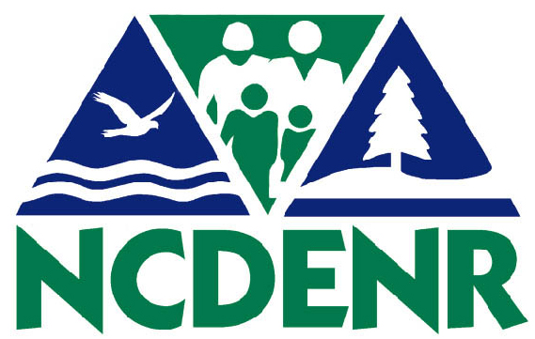
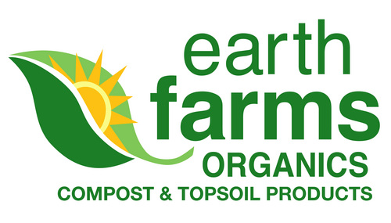
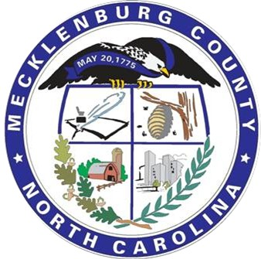
Scaling Up Composting in the Charlotte Region APPLICATION
Page 2

Participant Information (Estimates are acceptable):

Organization:
Primary Contact (Name & Title):
Secondary Contact (Name & Title):
Address:
Phone:
Email:
Primary Reason for Application (e.g., want to lessen our footprint, figure out how much waste we have, etc.):
Current Waste Management / Recycling Collection Set-up:
Waste Management / Recycling Costs:
Waste Management / Recycling Tonnage Data:
Are you interested in joining the EPA Food Recovery Challenge?
Any Additional Comments:

Next Steps
- Email completed Application to Anne.Bedarf@GreenBlue.org
- Project Contact to set up phone interview
- Jim Lanier of Earth Farms will set up initial on-site meeting and evaluation
- Participants will be invited to periodic calls for updates and peer-to-peer discussions

Primary Contact:
Anne Bedarf, Senior Manager • GreenBlue’s Sustainable Packaging Coalition
434-817-1424, ext. 314 • Anne.Bedarf@GreenBlue.org
www.charlottecompost.org

